Chapter 4, Problem 10.

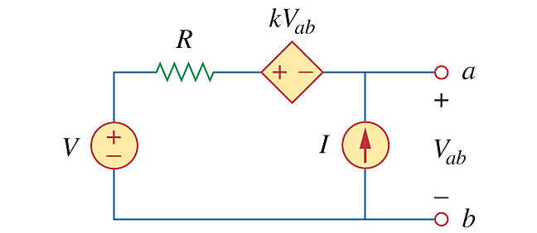
Using Fig. 4.78, design a problem to help other students better understand superposition. Note, the letter k is a gain you can specify to make the problem easier to solve but must not be zero.

Figure 4.78
For Prob. 4.10.

